User Manual
How to share a file



How to Securely Share a File with SpecterX
Sharing files with SpecterX works the same way on each and every platform. SpecterX integrates with your existing tools and apps to provide you with a seamless experience, while maintaining all of the preset security features.

Here are just a few examples:

Outlook
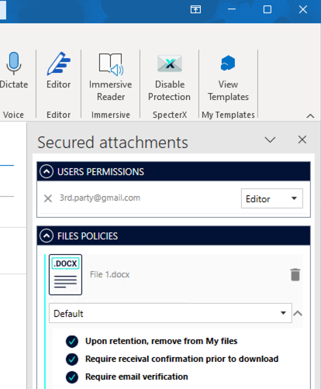

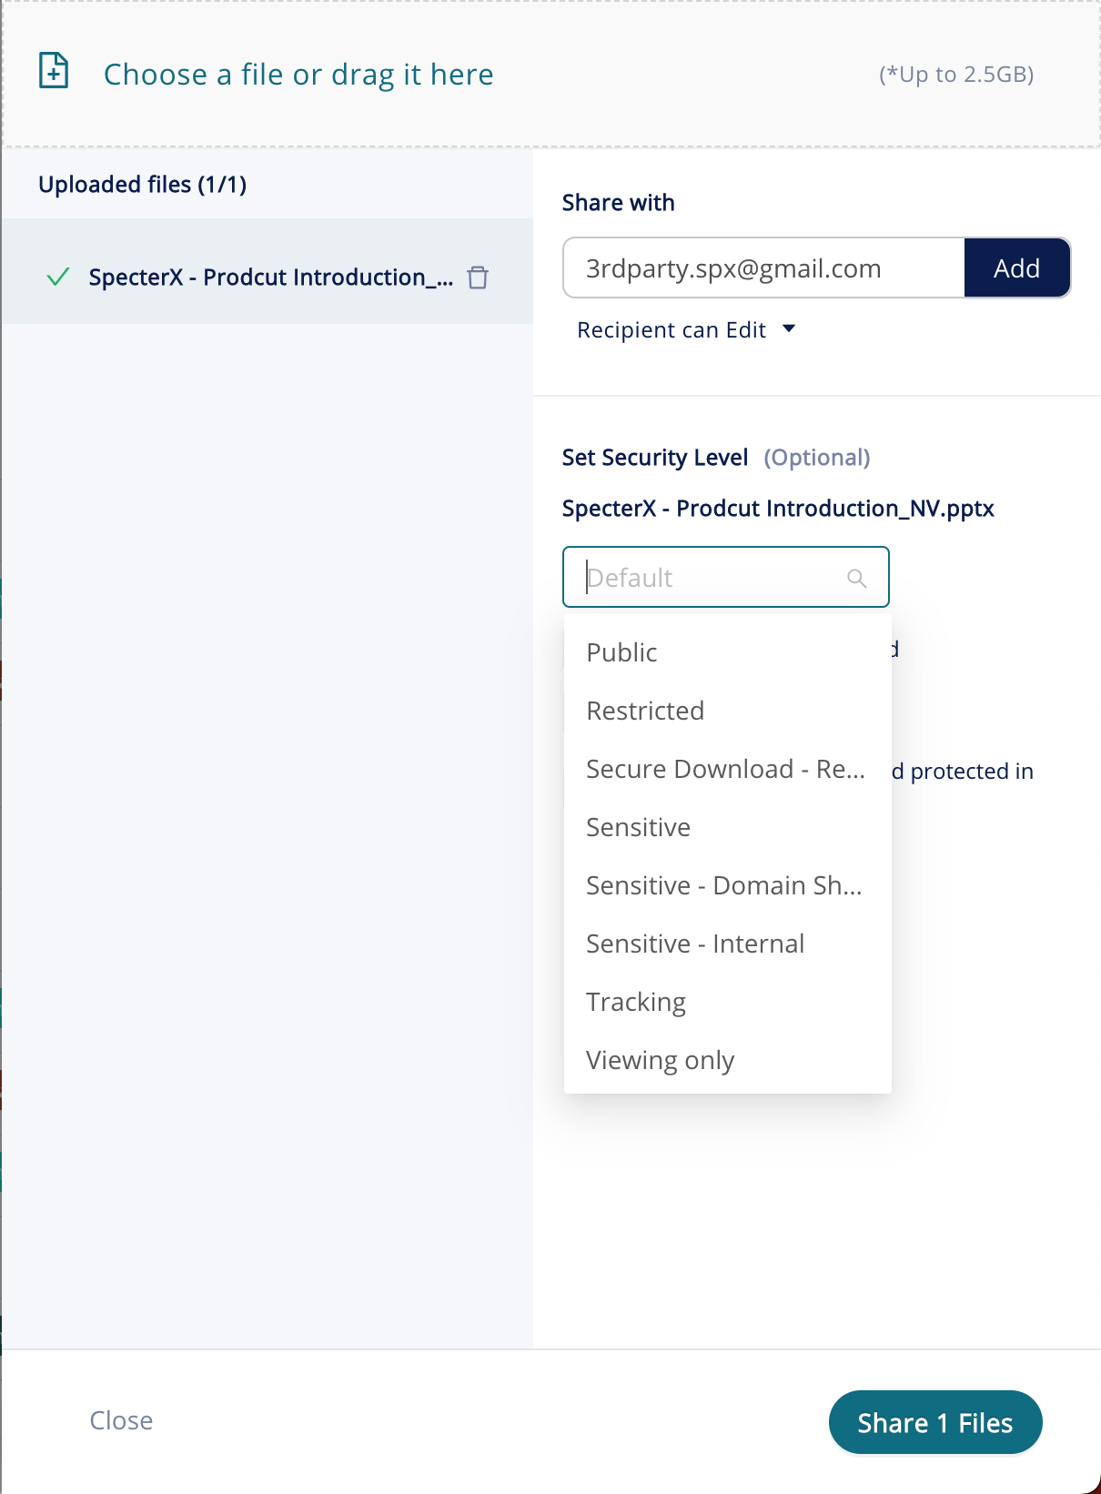
SpecterX Web Platform

Sharing a File Securely from Outlook

Install the SpecterX Outlook Add-in
Installing the Add-in is extremely easy.
If your system administrator hasn’t installed the Add-in for you yet, download the Add-in EXE file or ask your administrator to send you a copy. Once you receive it, double-click it and follow the instructions within the installer.


Protecting an Email
Now that you have the SpecterX Outlook Add-in installed it’s time to share a file!
In the Outlook top menu bar, you’ll see a new icon: SpecterX - Enable Protection
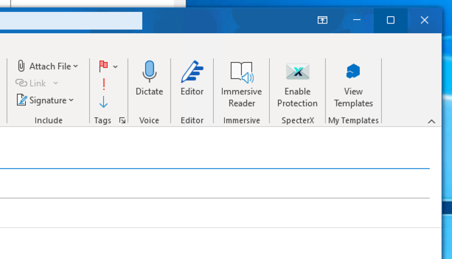
To share a file securely, write the list of recipients in the "To" / "Copy" fields (if necessary) and attach files, as you would normally.
To attach files, select the desired file for secure sharing and click on the "Open" button or click twice (double-click) on the desired file:
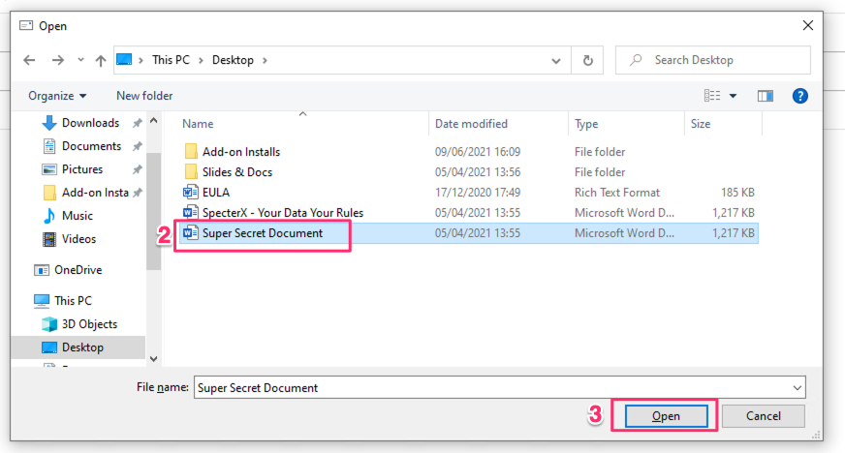

The ‘Secured attachments’ tab will open, and the original file will start uploading to SpecterX. A secure file will replace it.
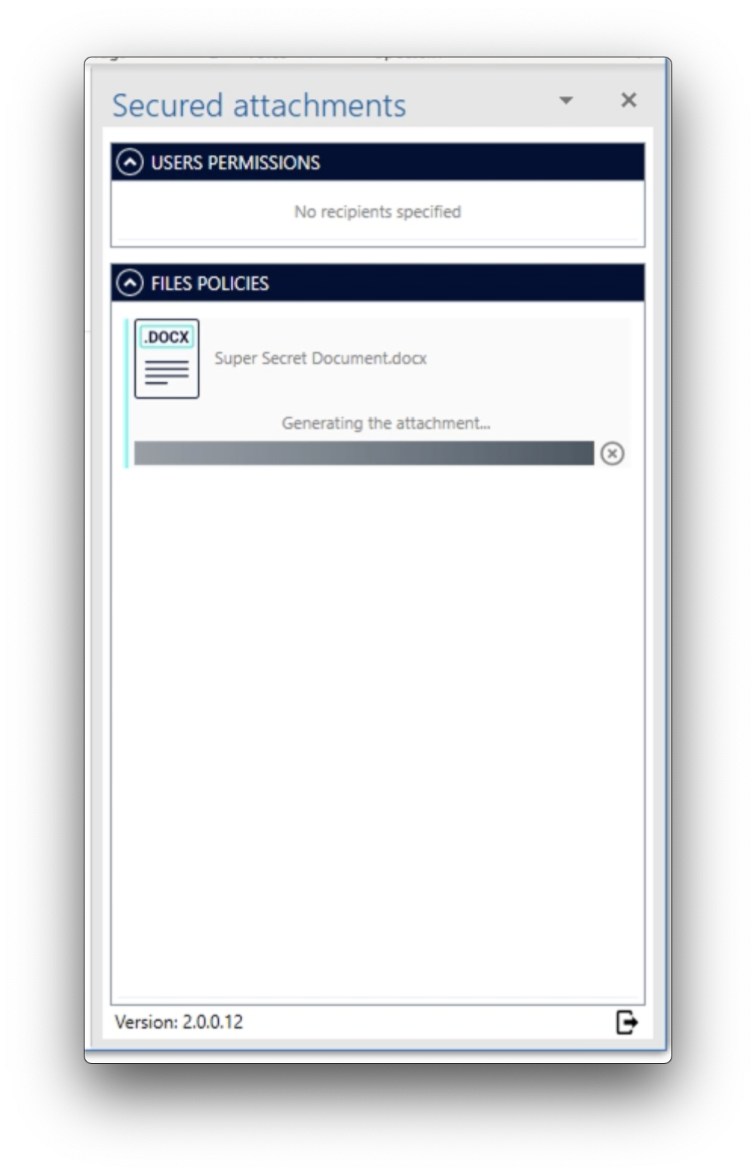
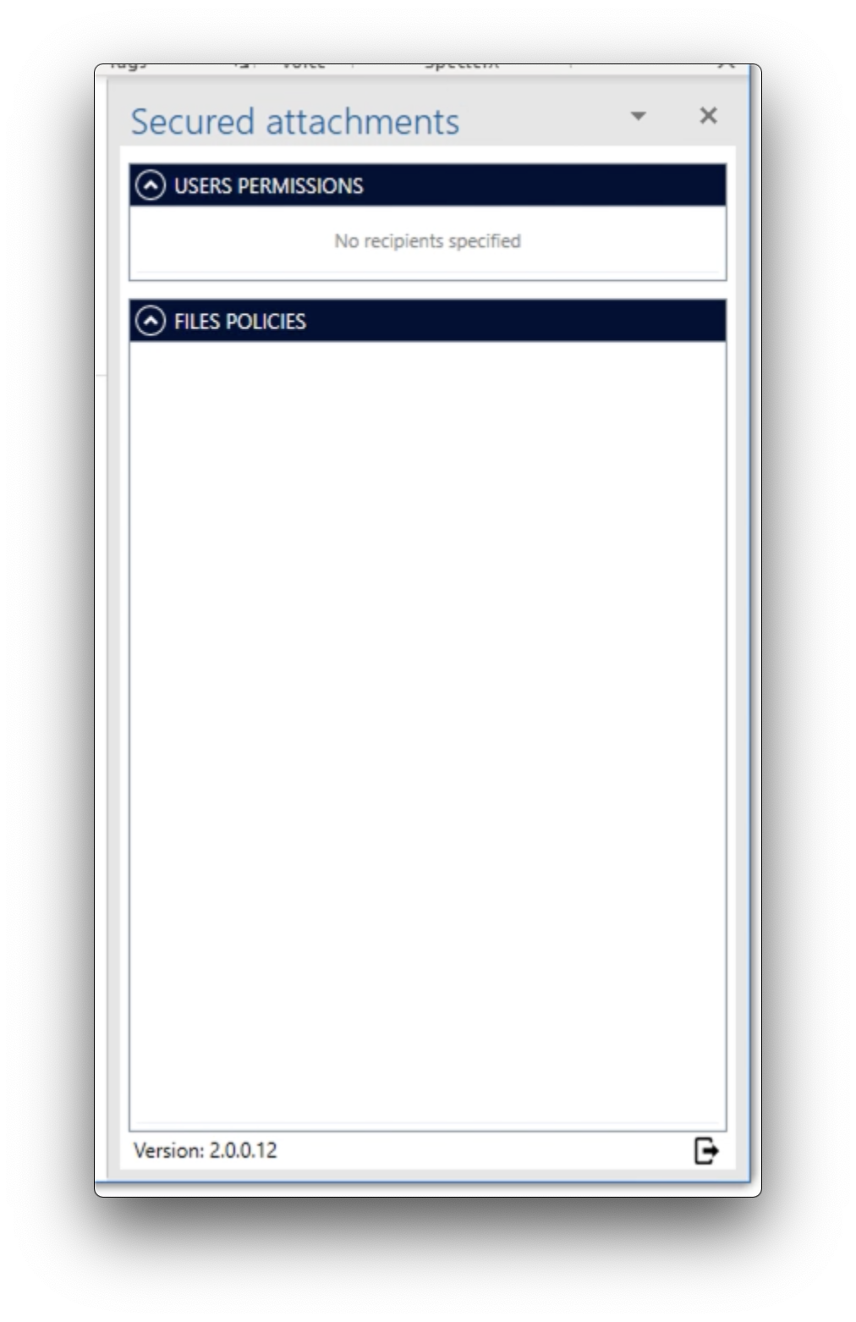
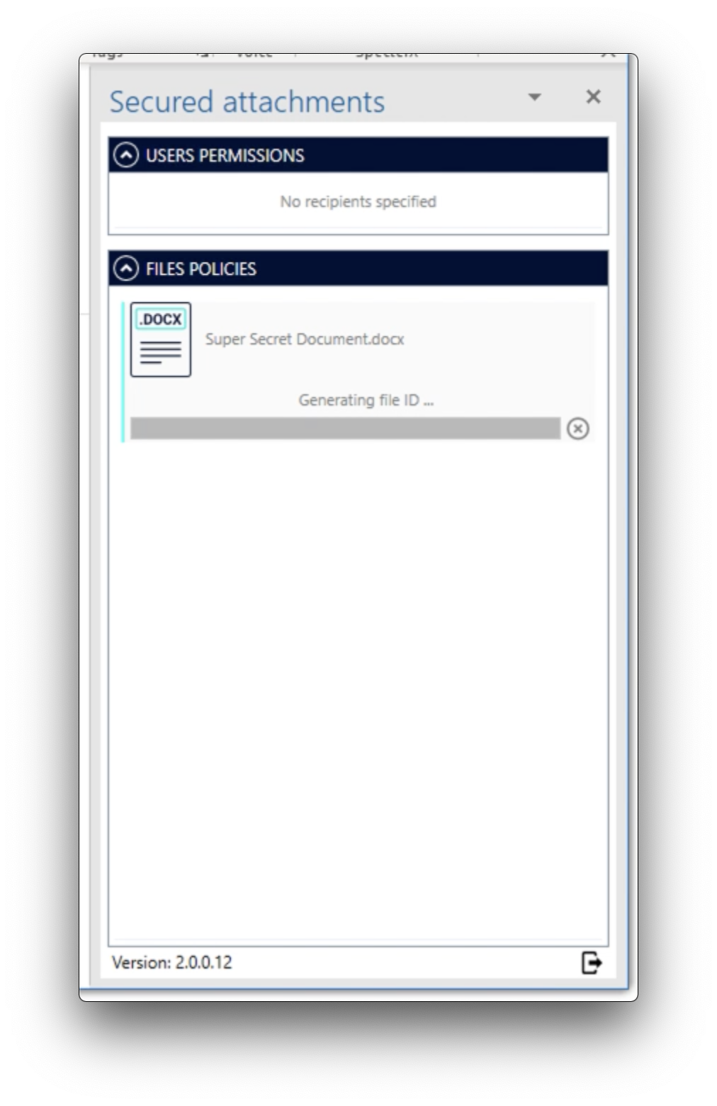
For each of the recipients added to the ‘To’, ‘CC’ and ‘BCC’ fields, you can choose the level of permissions they will have over the attached files.
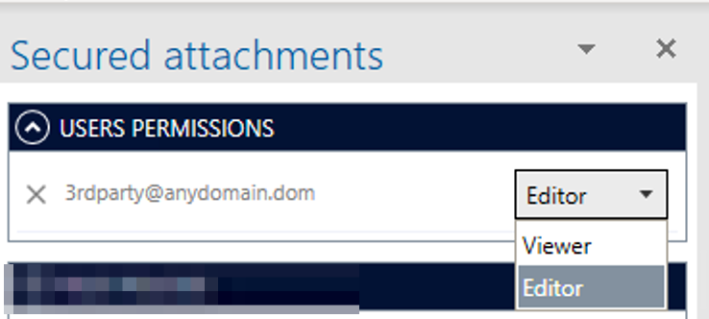

You can also choose a security policy for each file to match the file’s degree of security. Change policies by clicking the dropdown menu, or keep the Default policy assigned by the system admin.
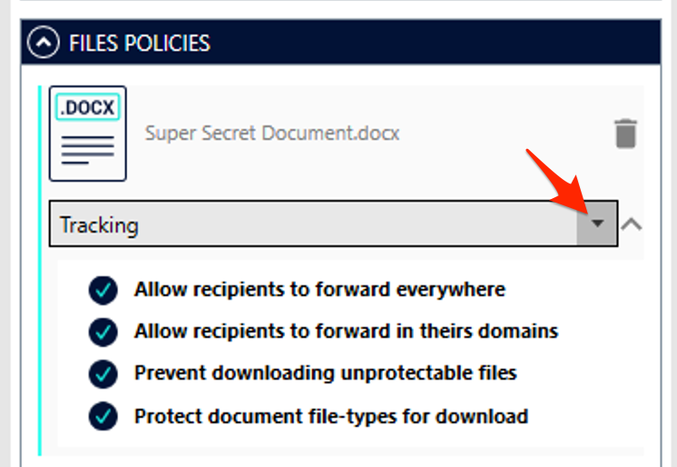

That’s it! You can compose your email and send it, knowing our attachments are secure.

Sharing files Securely from SpecterX Web Platform

Logging in to the SpecterX web platform
Log in to your tenant address https://specterx.migdal.co.il .
The identification process will be completed using your corporate identity.

Sharing a file
Click the ‘Share files’ button, placed at the right hand side of the screen
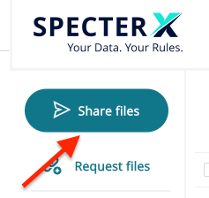

Drag your file / folder to the gray box or click on the box and select the files you would like to share

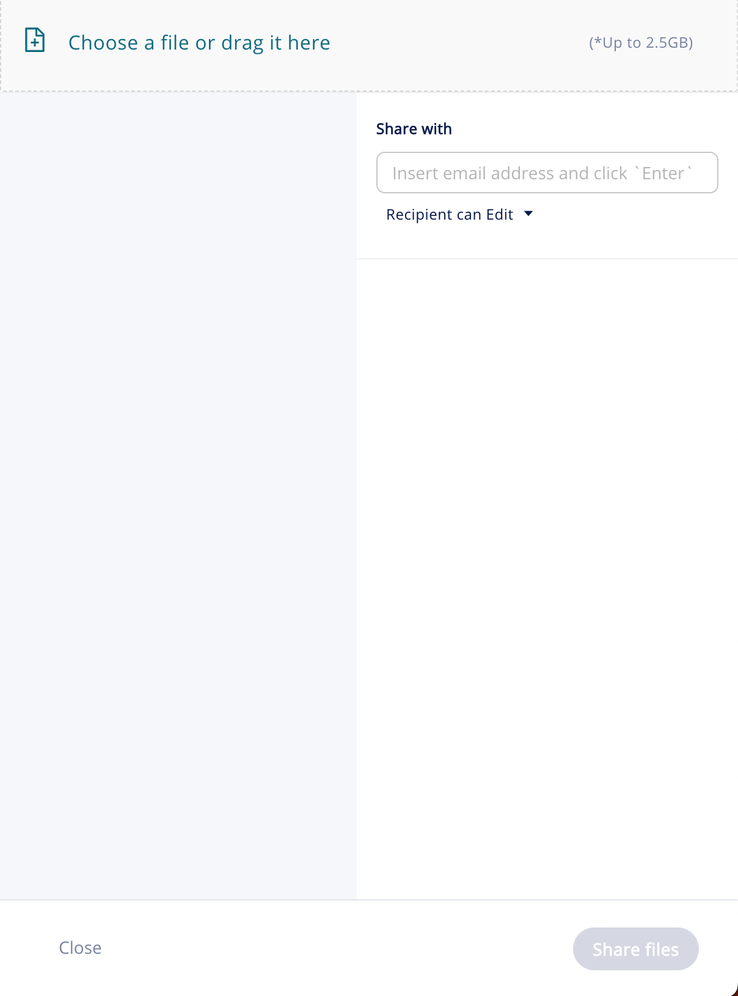
After choosing the files you would like to share, you’ll see an uploading progress bar. The file is now being uploaded to a secure location of your organization. This process will be complete once the progress bar turns green and reaches 100%.

Enter the recipient email address under the ‘Share with’ section and click Add, or click the ‘Enter’ button on your keyboard.
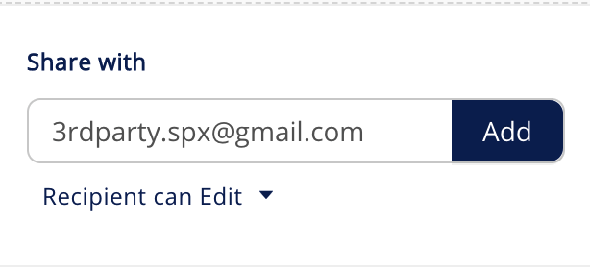

You can change the recipient’s usage permissions within the ‘Editor’ dropdown and choose if the recipients will receive an email notification from SpecterX
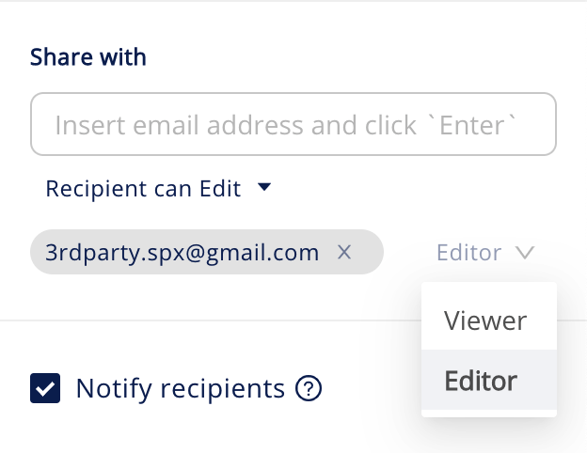

You can adjust the predefined policy for each file to determine how recipients will access and use the data
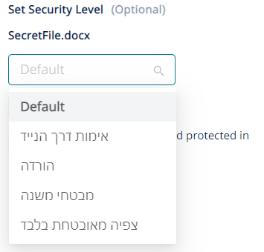

You can choose to apply the policy for the entire files/folders you uploaded by clicking the “Set for all” button

In order to share the file, click the ‘Share Files’ button at the bottom right corner


That’s it! You have shared your files successfully.
You may also want to copy the sharing link by clicking the ‘Copy to clipboard’ button, and use the link in your emails and instant-messages.

